PySpark

Cache
Cache stores intermediate results in memory, so Spark avoids recomputing transformations for multiple actions.
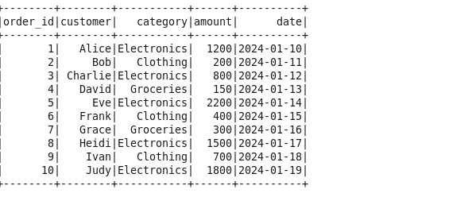
Without cache
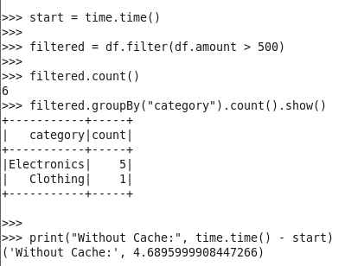
With cache
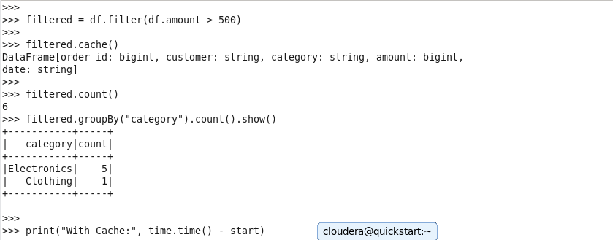
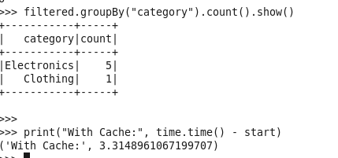

Shuffle
- Data movement across node
- Data is redistributed across partitions.
- So that similar data goes to the same place.

Broadcast Join

- Sending small dataset to all nodes to avoid shuffle
- Small table is broadcasted (copied)
- Large table stays where it is
- Join happens locally → no shuffle
- Use when one table is small, and the other is large.

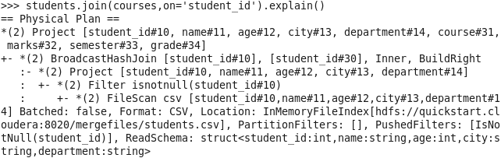
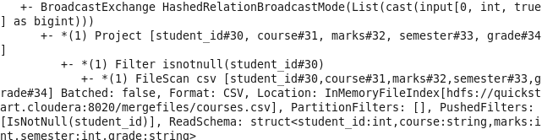

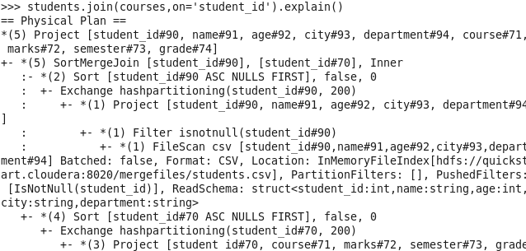

Disable Broadcast join:

spark.conf.set("spark.sql.autoBroadcastJoinThreshold", -1)

BroadCast Manually:

from pyspark.sql.functions import broadcast
students.join(broadcast(courses), on="student_id")

Partition
- Chunk of data stored across node
- Spark divides data into multiple partitions for faster processing, use multiple CPUs
- Type:
  - Default
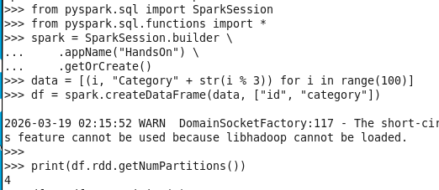

  - Custom → We declare the no.of.partitions
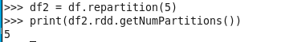

RePartition vs Coalesce
RePartition
- increases or decreases partition with shuffle
- reshuffle data to balance partitions
- df.repartition(200)

Coalesce
- reduces partitions without shuffle
- df.coalesce(10)

Catalyst Optimizer
- Spark SQL’s query optimization engine
- It takes your query and:
  - Analyzes it
  - Optimizes it
  - Generates the best execution plan

Data Skew
- Data skew occurs when data is unevenly distributed across partitions, causing performance bottlenecks in distributed processing.
- Handled by:
  - Salting
  - Repartition
  - Broadcast join
  - Skew join handling
  - Filter heavy keys

PySpark Configuration optimization
- Executor Configuration:
Driver → Assign Tasks → Executors
Avoid too many executors.
More Small executors > few big Executors
Balance Memory and cores
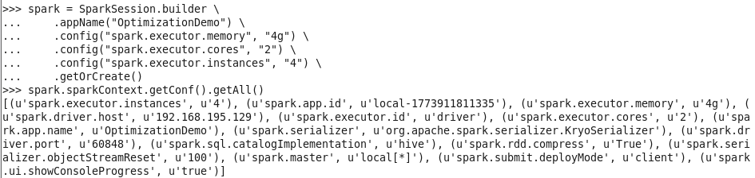
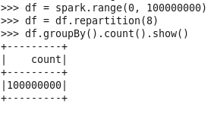

- Shuffle Partitions:
Shuffle partitions control how many partitions Spark creates after a shuffle operation like groupBy or join
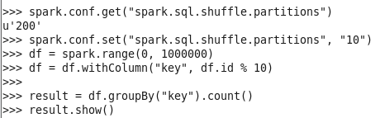
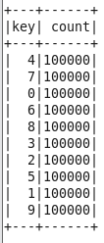

- Serialization:
Converting objects into byte stream (binary format) so they can be:
- Sent over network
- Stored in memory/disk
In PySpark, data is constantly moved between:
Driver ↔ Executors
Executors ↔ Executors
Types:
- Java serialization
- Kryo serialization
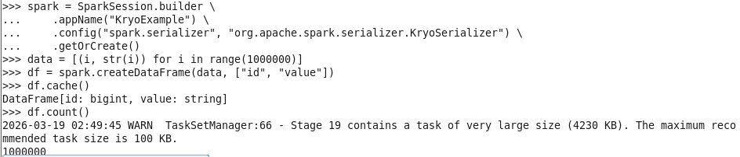
4. Adaptive Query Execution
AQE allows Spark to change execution plan at runtime based on actual data.
Ex: Google Maps
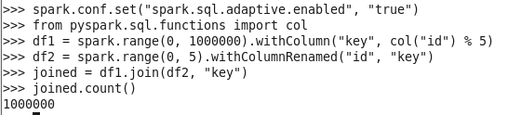
Deployment modes:
Where the Driver program runs
Types:
- Client mode
- Cluster mode

